1. Create Basic Workflow.

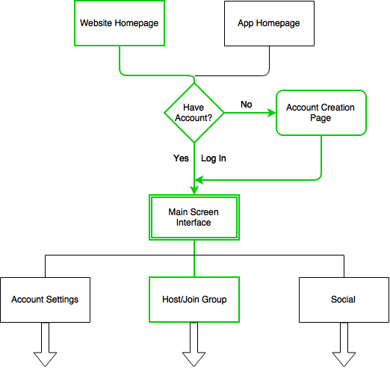

1. Create Photoshop sketches of boxes highlighted in green.
2. Implement front end HTML, CSS and basic JS.
3. Link all green boxes, omit need for account credentials.